
WEEK 4 PRAC
Lerato Modise 20260925


Screenshot of the topology
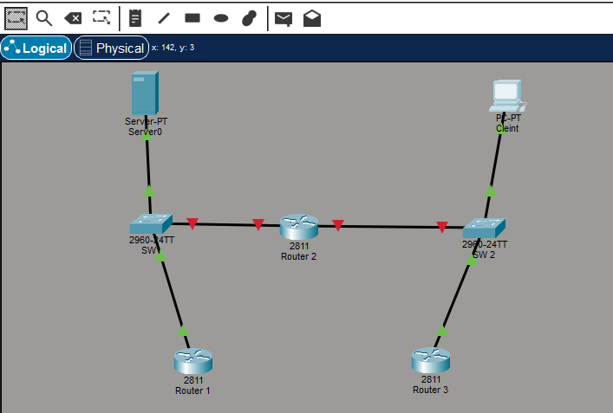
Attempted to reach the DNS server
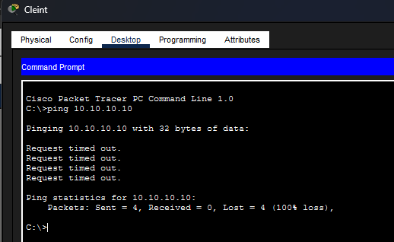
My partner switched off Router 2, and I had to configure the DNS server to reach the PC client. I also tested the OSI layers to check if they would function correctly when my topology is active.

Data link layer
Client PC

Router
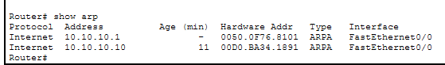
Network Layer
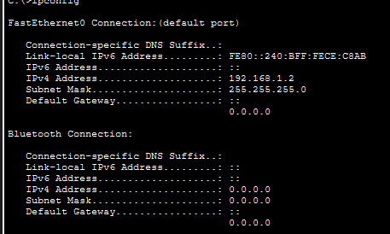

Got the solution
